Live/Dead Cell Fiji (or ImageJ) Analysis

Software: <https://imagej.net/Fiji> (Fiji = newer ImageJ)

Scripting Tutorial for Modifications: <https://www.ini.uzh.ch/~acardona/fiji-tutorial/#s1> (aim to use python/ Jython)

Java API useful for modifications: <https://javadoc.scijava.org/>

**How to Run**

1. Make sure Fiji (ImageJ) is downloaded and available on the computer to run the analysis. Open Fiji.
2. Once loaded, open the script in Fiji and navigate to the LDCell_Count.py file  
   

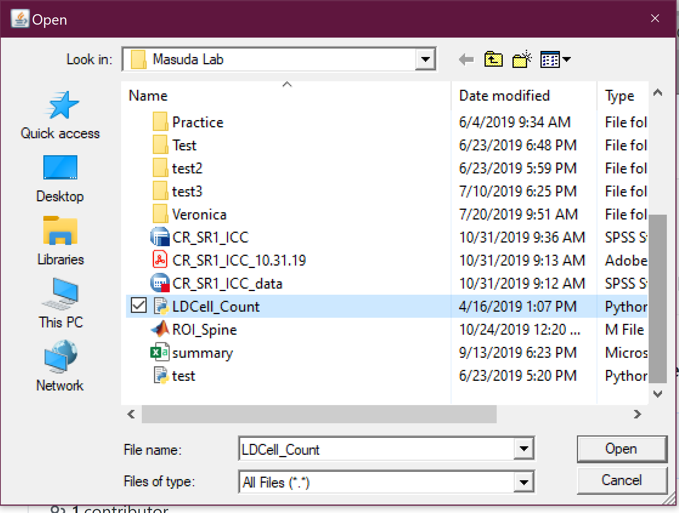

1. The following window with the script should open. Click on Run in the bottom left (circled in red)

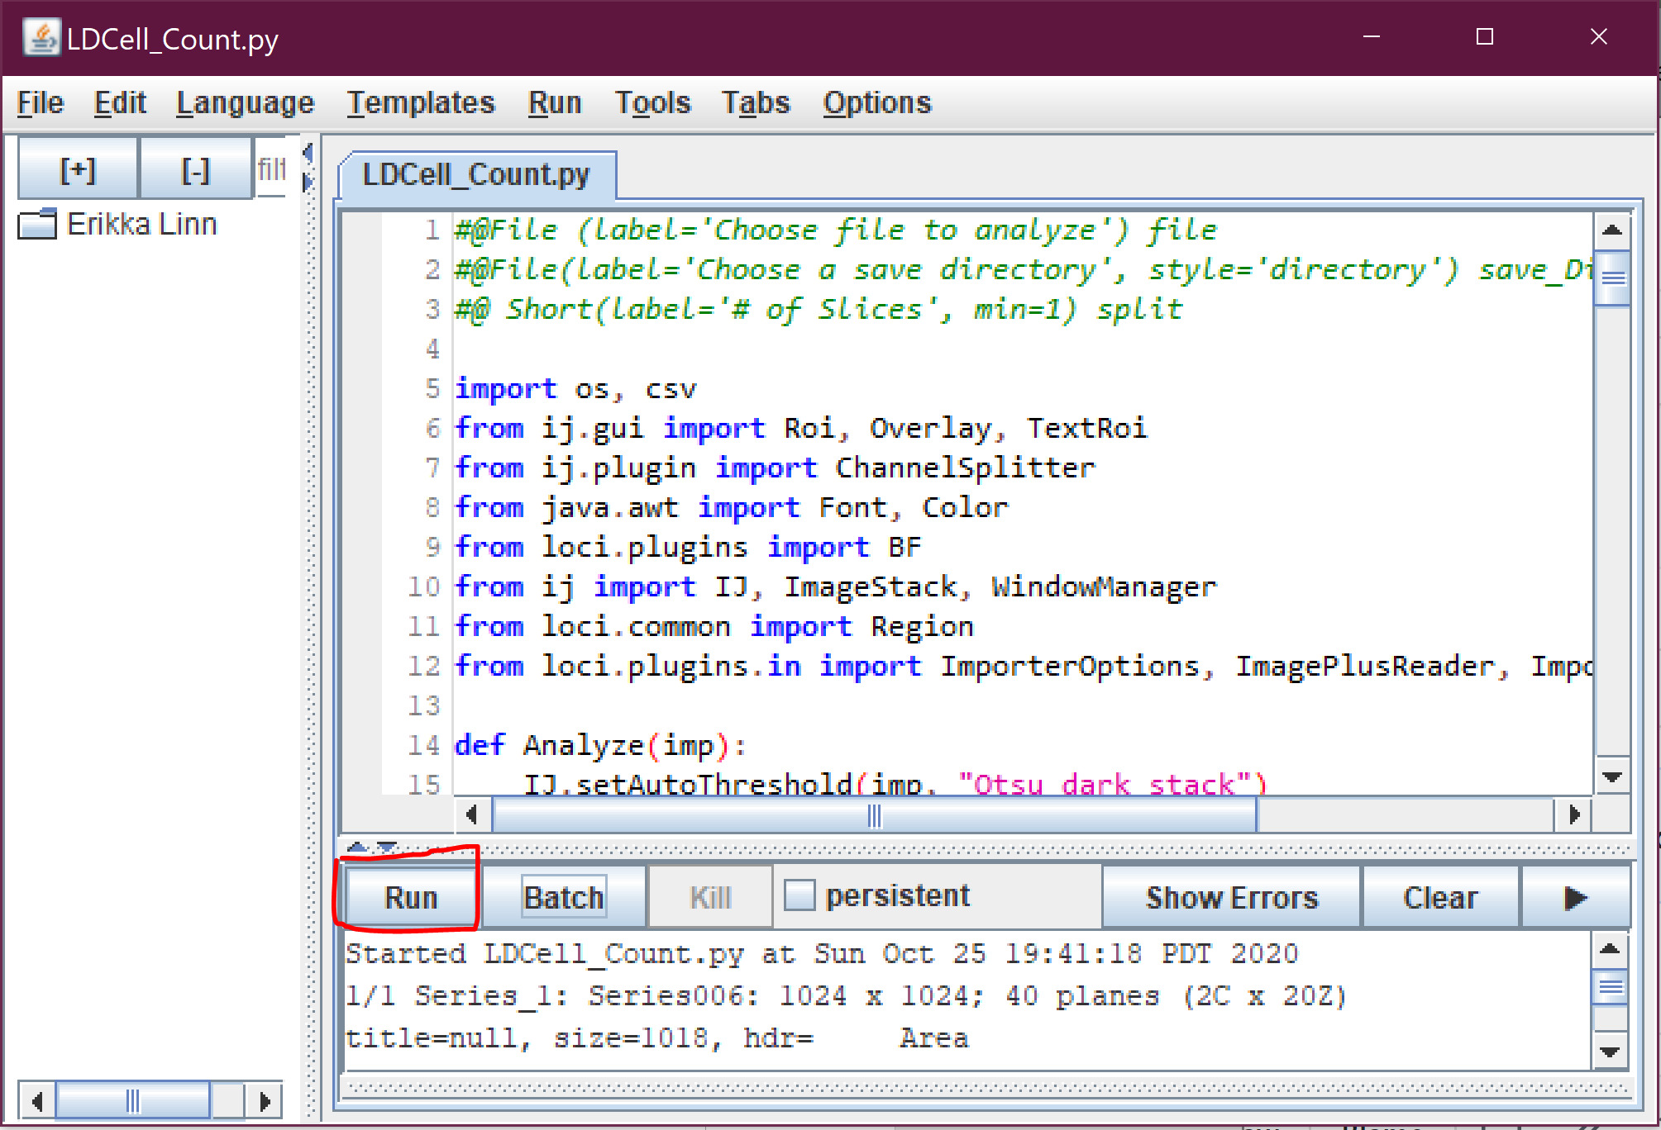

1. In the Pop-up that appears do the following:
   1. First select the file you want analyzed
   2. Then choose a directory for the results to go into
   3. Finally decide how many slices you want to remove from the top and bottom of the images.
   4. Click ok and the program will run.

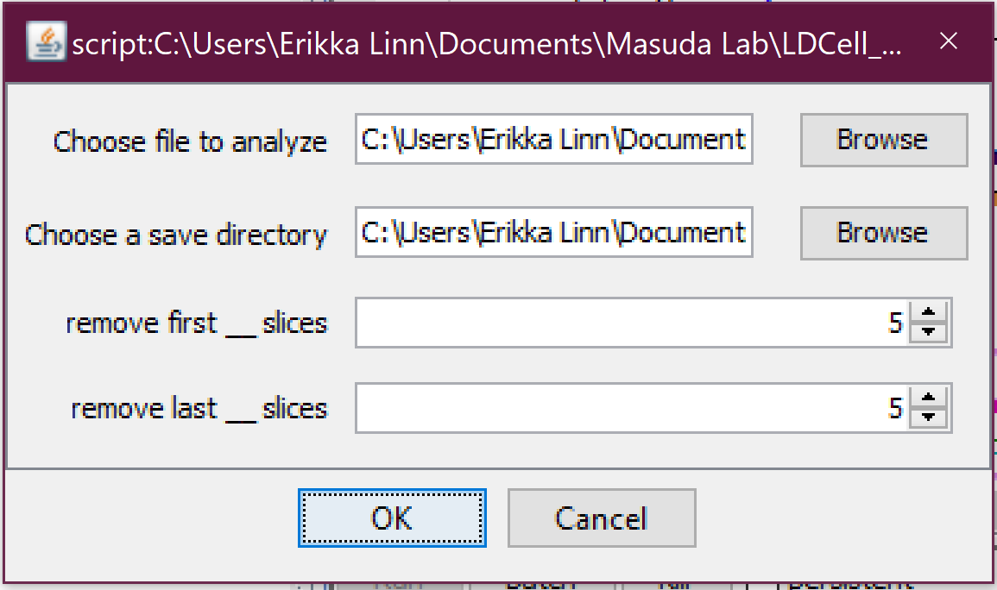

1. Once the program completes, go to the results folder and look at the screenshots/excel file for more information.

Some Things I looked at when making this:

<https://www.ncbi.nlm.nih.gov/pmc/articles/PMC4041579/#R17>

<https://journals.sagepub.com/doi/full/10.1369/jhc.4A6511.2005?url_ver=Z39.88-2003&rfr_id=ori%3Arid%3Acrossref.org&rfr_dat=cr_pub%3Dpubmed>

<https://brtilifesciences.com/PDF/Quantification%20of%20Live_Dead%20Staining%20Using%20Fiji%20software.pdf>

<https://github.com/imagej/imagej-scripting/blob/master/src/main/resources/script_templates/Tutorials/Wiki_Jython_Tutorial_1.py>

Jadin KD, Wong BL, Bae WC, Li KW, Williamson AK, Schumacher BL, Price JH, Sah RL. Depth-varying density and organization of chondrocyte in immature and mature bovine articular cartilage assessed by 3-D imaging and analysis. J Histochem Cytochem. 2005;53:1109–1119. PMID: 15879579. [[Link](https://journals.sagepub.com/doi/full/10.1369/jhc.4A6511.2005?url_ver=Z39.88-2003&rfr_id=ori%3Arid%3Acrossref.org&rfr_dat=cr_pub%3Dpubmed)]

“Three-dimensional imaging and image processing of articular cartilage allows for direct assessment of cell organization in tissue volumes of various sizes and geometries ([Figure 1](https://journals.sagepub.com/doi/full/10.1369/jhc.4A6511.2005?url_ver=Z39.88-2003&rfr_id=ori%3Arid%3Acrossref.org&rfr_dat=cr_pub%3Dpubmed)). With **confocal microscopy**, successive thin z-sections are obtained by axial motion of the sample stage, allowing for capture of registered serial sections. However, even with laser-based multi-photon systems, imaging depth into the tissue is *limited by diffusion and scattering of light*, typically ≃100 μm in cartilage ([Figure 1A](https://journals.sagepub.com/doi/full/10.1369/jhc.4A6511.2005?url_ver=Z39.88-2003&rfr_id=ori%3Arid%3Acrossref.org&rfr_dat=cr_pub%3Dpubmed)) ([Wong et al. 2001](https://journals.sagepub.com/doi/full/10.1369/jhc.4A6511.2005?url_ver=Z39.88-2003&rfr_id=ori%3Arid%3Acrossref.org&rfr_dat=cr_pub%3Dpubmed)). A relatively new technique**, digital volumetric imaging (DVI)**, overcomes this limitation via surface imaging microscopy, wherein volumes are obtained by physical sectioning and imaging the surface of fluorescently stained tissue embedded in an opaque polymer ([Ewald et al. 2002](https://journals.sagepub.com/doi/full/10.1369/jhc.4A6511.2005?url_ver=Z39.88-2003&rfr_id=ori%3Arid%3Acrossref.org&rfr_dat=cr_pub%3Dpubmed)). With this method, a large tissue volume, with depths effectively unlimited and practically up to several millimeters, can be imaged at high resolution ([Figure 1B](https://journals.sagepub.com/doi/full/10.1369/jhc.4A6511.2005?url_ver=Z39.88-2003&rfr_id=ori%3Arid%3Acrossref.org&rfr_dat=cr_pub%3Dpubmed)). With 3D data from such methods, 3D image-processing methods could be used to identify tissue features (e.g., cells) and quantify their organization. Automation and standardization of such methods would be useful to analyze samples quickly and repeatably.”